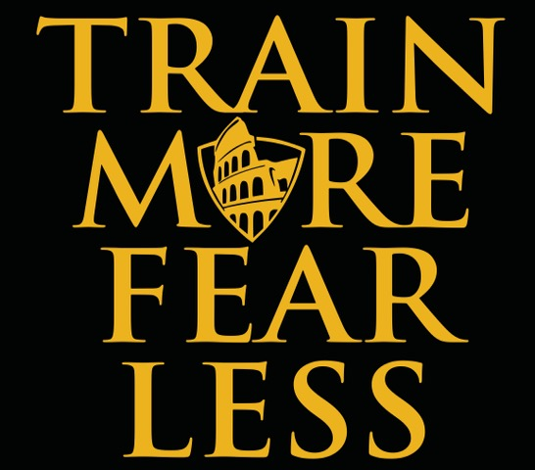

Name: ____________________________________________

“Little by little, a little becomes a lot.” – Tanzanian Proverb

**Fitness Goals** What can you do? What do you want to improve?

Examples: push-ups, knee grabs, squats, etc.

|  |  |
| --- | --- |
| **Goal** | **Actions to achieve goal** |
|  |  |
|  |  |

**Health Goals**

Examples: body composition, cholesterol, weight, improving blood work from doctor, etc.

|  |  |
| --- | --- |
| **Goal** | **Actions to achieve goal** |
|  |  |
|  |  |

**Finance Goals**

Examples: income, debt reduction, retirement

|  |  |
| --- | --- |
| **Goal** | **Actions to achieve goal** |
|  |  |
|  |  |

**Family or Relationship Goals**

Examples: Reconnect with friends/family, dedicated time with friends/family, etc.

|  |  |
| --- | --- |
| **Goal** | **Actions to achieve goal** |
|  |  |
|  |  |

**Fun Goals** How will you have some healthy fun?

Examples: vacations, events, etc.

|  |  |
| --- | --- |
| **Goal** | **Actions to achieve goal** |
|  |  |
|  |  |